**Task 7 for submission (parts A,B,C & D)**

**PART A**

In a paragraph (approx. 100 words), **explain** the steps in the accounting process and their relationship to each other.

Source documents are collected to verify that transactions have occurred. These documents are used to whether transactions are debit or credit and enter them into a journal.

Journals are then used to post to the ledger accounts (individual accounts for each account). The ledger account provides you with individual account balances at a point-in-time. The trial balance is prepared to check the arithmetic accuracy of the ledger and ensure that double entry has taken place at a set date.

**PART B**

Theresa Green operates *Green’s Tree Solutions* whose core business is tree lopping and tree removal.

During the month of March, the following transactions occurred:

|  |  |
| --- | --- |
| Mar 1  3 | Theresa contributed $45,000 cash to the business.  *Oakey Hardware* sold supplies to *Green’s Tree Solutions* for $250. |
| 8 | Terry Porter paid $1,200 for service revenue. |
| 10 | Machinery was purchased for $25,000 cash. |
| 23 | Paid *ALG* for electricity account$415. |
| 24 | Purchased supplies for $560 |
| 25 | *ALG* returned the cheque issued on 23 February, advising that the amount should have been $451. The original cheque was cancelled and a new cheque was prepared for the correct amount. |
| 27 | Paid *Telstrus* for internet account $190. |
| 28 | Theresa withdrew $200 from her business’s bank account for personal use. |

You are required to **apply** transaction analysis and double entry principles to:

* record the above listed transactions in the general journal (include narrations)
* post the general journal entries to the T format ledger
* prepare a trial balance

**Excel file

**PART C**

You are required to **analyse and interpret** the general ledger below then select the correct response to the questions that follow.

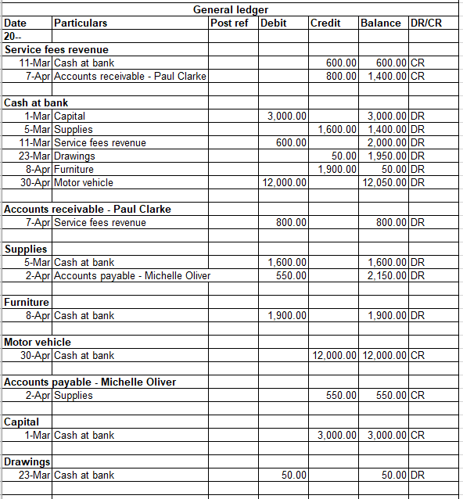

**Q1**

What type of account is Supplies?

1. Asset
2. Liability
3. Revenue
4. Expense

**Q2**

Which transaction has not been recorded in the general ledger:

1. Purchased supplies for cash $1600
2. Owner invested $3000 cash
3. Performed service on credit for $600
4. Owner withdrew cash $50

**Q3**

As at 5 March, the accounting equation can be represented as:

1. A $3,000 = L $1,400 + OE $1,600
2. A $1,400 = L $0 + OE $1,400
3. A $1,600 = L $0 + OE $1,600
4. A $3,000 = L $0 + OE $3,000

**Q4**

Select the account rule that has been applied to the transaction on 8 April:

1. Bank account is an asset increasing, therefore it is DR; Furniture at Cost account is an asset decreasing, therefore it is CR
2. Bank account is an asset increasing, therefore it is DR; Furniture at Cost account is an expense increasing, therefore it is CR
3. Furniture at Cost account is an expense account increasing, therefore it is DR; Bank account is an asset decreasing, therefore it is CR.
4. Furniture account is an asset increasing, therefore it is DR; Bank account is an asset decreasing, therefore it is CR

**Q5**

Select the account rule that has been applied to the transaction on 30 April:

1. Bank account is an asset increasing, therefore it is DR; Motor Vehicle at Cost account is an asset decreasing, therefore it is CR
2. Bank account is an asset increasing, therefore it is DR; Motor Vehicle at Cost account is an expense increasing, therefore it is CR
3. Motor Vehicle at Cost account is an expense account increasing, therefore it is DR; Bank account is an asset decreasing, therefore it is CR.
4. Motor Vehicle at Cost account is an asset increasing, therefore it is DR; Bank account is an asset decreasing, therefore it is CR

**Q6**

If a trial balance was prepared from this ledger, the totals for both debit and credit columns would be:

1. $15,600
2. $16,950
3. $20,500
4. $12,050

**PART D**

The Trial Balance below for Coolum Air Conditioning does not balance.

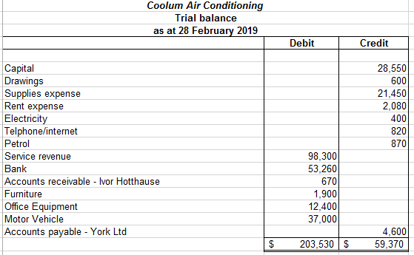

You are required to **analyse** the trial balance to locate all errors.

Amend the trial balance so that it balances and is correctly presented.

Assume that all account balances are the correct amount and account balances should be of their normal nature.

**Excel File